Walsh College User Documentation

how to access The Walsh college website

|  |  |
| --- | --- |
| Raised hand with solid fill | The purpose of this tutorial is to show unaccustomed users how to access the Walsh College Portal. By following the following steps, new users will successfully be able to navigate, log in, view, and utilize the services provided to Walsh College users. |

# Overview

|  |  |
| --- | --- |
| Raised hand with solid fill | * Step #1   Open your web browser of choice and navigate to <https://walshcollege.edu/> |

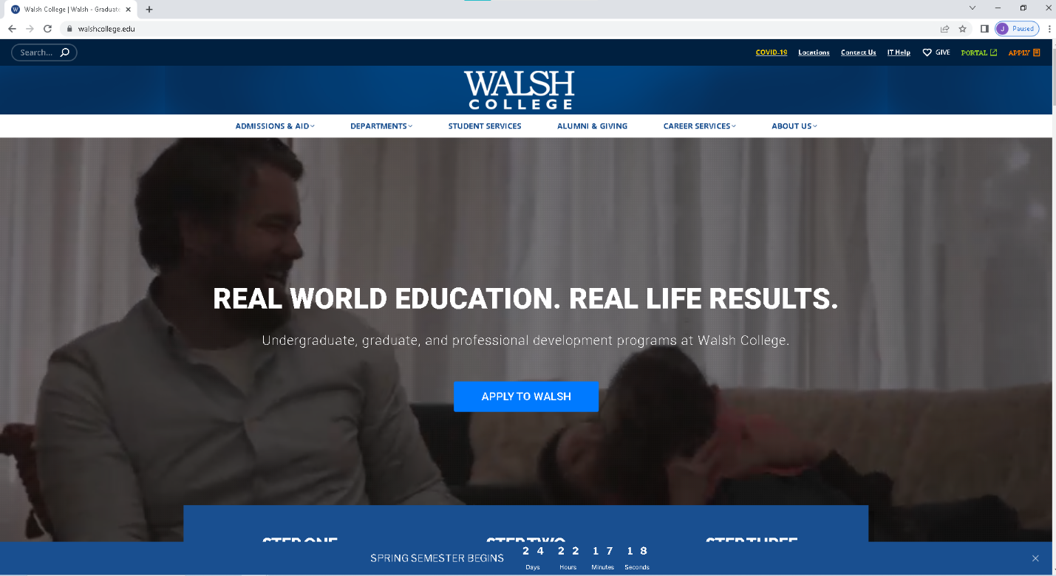

* Step #2

Next, navigate to the upper right-hand side of the webpage and use the mouse to left-click the “Portal” option.

* Step #3

After left clicking the portal option you will be taken to the following login page:

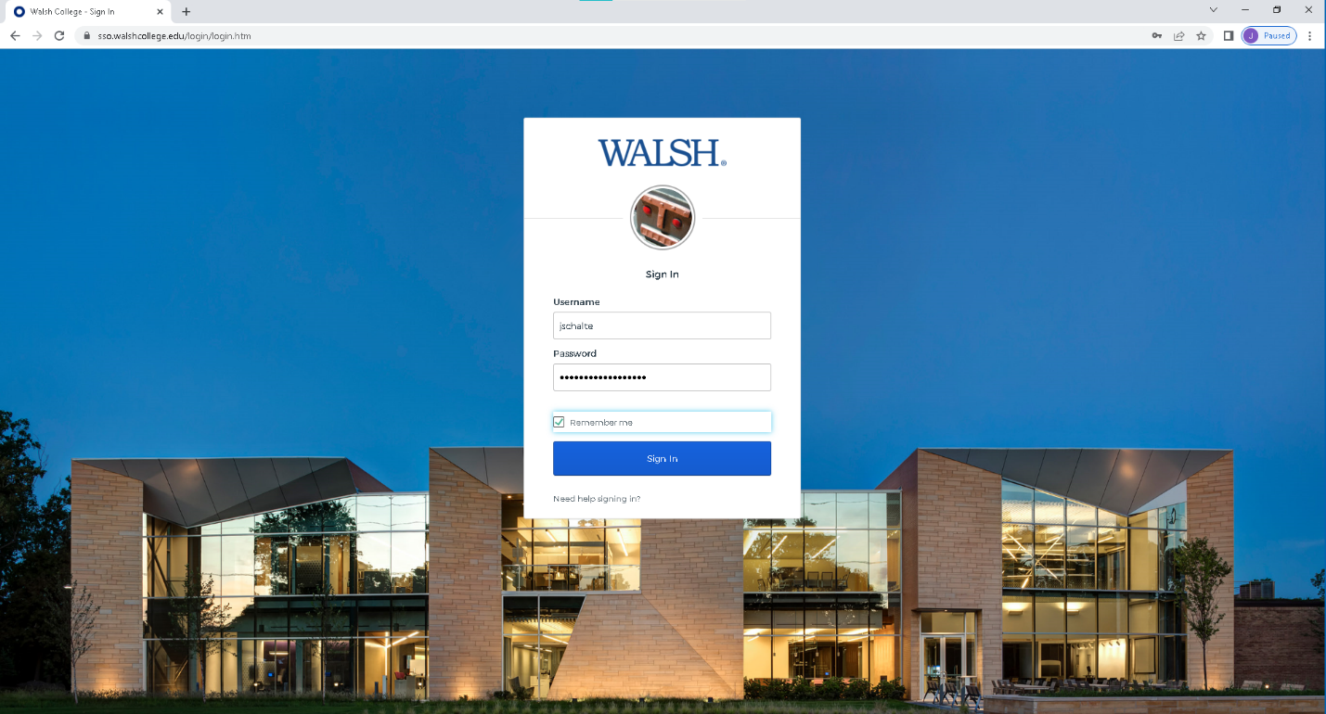

Enter your Walsh College username or email, and then enter your password. Once you are done, use the left-click on the mouse to click “Sign in”, or hit the enter key.

Congratulations! You are now logged into the Walsh College website portal and are free to access all of the resources available to you as a Walsh Student or Alumni.

Jordan Schalter

Konja IT402

Assignment 8: User Documentation

03/09/23